Jump Starter

LED Light Upgrade

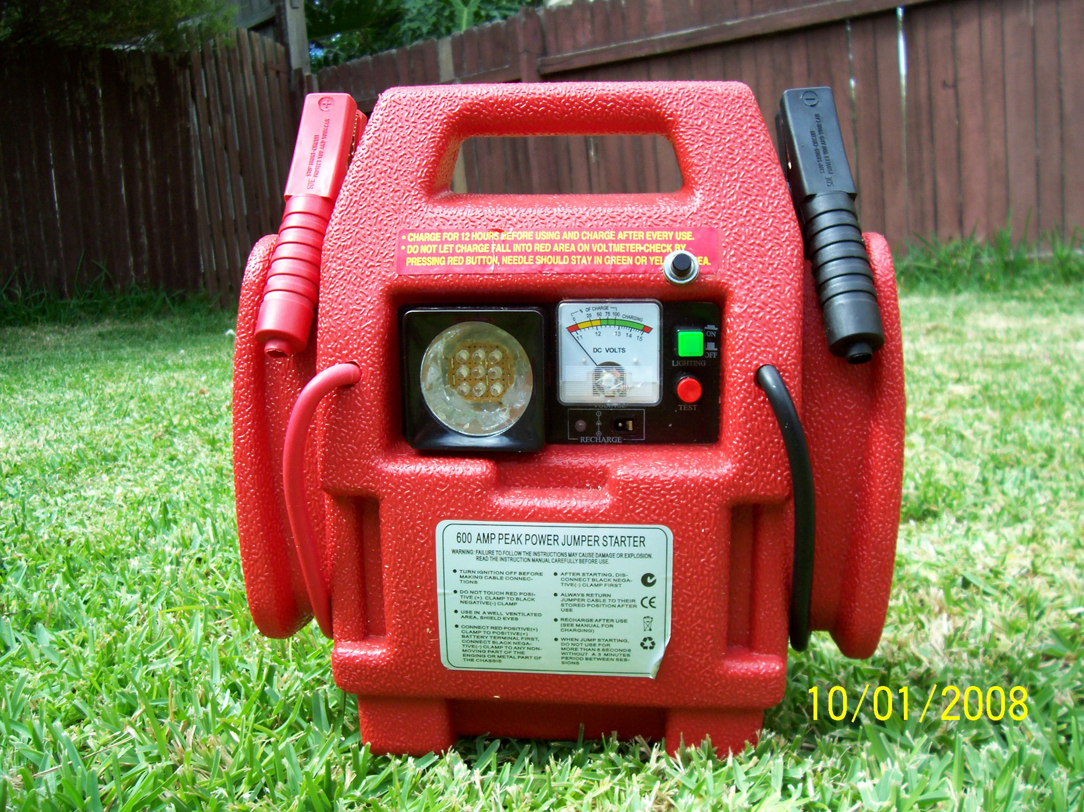

Table of Contents
Table of Figures 2
Jump Starter Overview 3
The Lamp 4
The Microcontroller Used 4
LED PCB (Vero board) Description 5
Controller PCB (Vero board) Description 6
Putting The Hardware Together & Testing 7
Program Description 9
Source Code 11
Circuit Diagram 14

Table of Figures
Figure 1 – Current drawn from 12V supply 6
Figure 2 – Minimum to Maximum Brightness cycles 10
Figure 3 – LED Bank Illumination Switch Depressions 10

Document History

Rev | Date | Description
1.0 | 25-Jan-08 | Originating document

Jump Starter Overview
Where to start? I live in Australia in the state of NSW (New South Wales) in a suburb called Wyoming (very close to the city of Gosford) and love going on camping trips up the Hawkesbury River by boat with friends. We will usually go on a trip lasting 2 to 3 nights and get up around 7am or 8am and….have breakfast, drink coffee, fish, drink beer, have a rest, drink beer, have a walk around the bush, drink beer, get some fire wood, drink beer, have lunch, drink beer, fish, drink beer, etc.

The Jump Starter used is a red coloured unit and was purchased from Supercheap Auto, on special for AU$40, and has a 12V 12 Amp Hour battery as the source.

As purchased the unit has:
- 12V 12 Amp Hour battery
- 240V powered battery charger (plug pack)
- a meter for measuring the voltage of the 12V source
- an incandescent lamp for illumination
- a female 12V jack for powering plugged devices
- a set of clamps for connecting to a battery

This device has found itself very useful in camping situations (I’ve never used it for jump starting a car) where power for a DVD player, radio or an external lighting source was needed. In my case it was for lighting within my tent.

One thing that was disappointing was the incandescent lamp. It consumed quite a lot of power, 8 watts, and as such was not really all that bright. Since I had purchased a number of 20,000 mCandela white LED’s from Oatley Electronics (www.oatleyelectronics.com.au) I decided to replace the incandescent light with a 9 LED Vero board. Further to that I thought that I could also add a pushbutton and a Microcontroller Vero board to allow brightness control.

Rather than make up a PCB I have built everything on Vero board. I haven’t supplied any details of the Vero board circuits because there are so few components it’s not really a problem to make up your own and you will probably do a better job than me!

The Lamp
The original lamp was an incandescent type that was not very bright and consumed about 8 watts. To make the unit more useable on a camping trip the lamp has been replaced with a 9 white LED microcontroller module with each white LED rated at 20,000 mCandela at 20 mA. This will provide a better light source than the original lamp whilst being adjustable and consuming a minimum of 15 milliamps to a maximum of 60 millamps of current at 12V. This will equate to:

Power = Voltage x Current

For 15 milliamps usage:
P = 12 x 0.015
P = 0.18W

For 60 milliamps usage:
P = 12 x 0.06
P = 0.72W

The Microcontroller Used
The microcontroller used is the 8 pin Atmel Tiny15. This microcontroller has the following features and peripherals:
- 1K flash (program) memory
- 32 registers (use these for RAM)
- 64 bytes EEPROM (not used)
- 4 channel 10 bit ADC (not used)
- Up to 6 I/O lines (4 used)
- Internal 1.6MHz oscillator

LED PCB (Vero board) Description
The LED PCB has 9 LED’s arranged as 3 branches of 3 LED’s driven in series. With a voltage drop of approximately 3.3V per LED this means that 9.9V is used in turning on each LED branch. To limit the current to 20 mA per LED branch means putting in a series resistor:

Resistance = Voltage / Current
R = 12V – 9.9V / 0.02
R = 2.1V / 0.02
R = 105Ω

By using a standard 100Ω resistor on the microcontroller PCB, when the on resistance of the BSN254A Enhancement FET (5Ω) is taken into account, we have 105Ω total series resistance per branch.

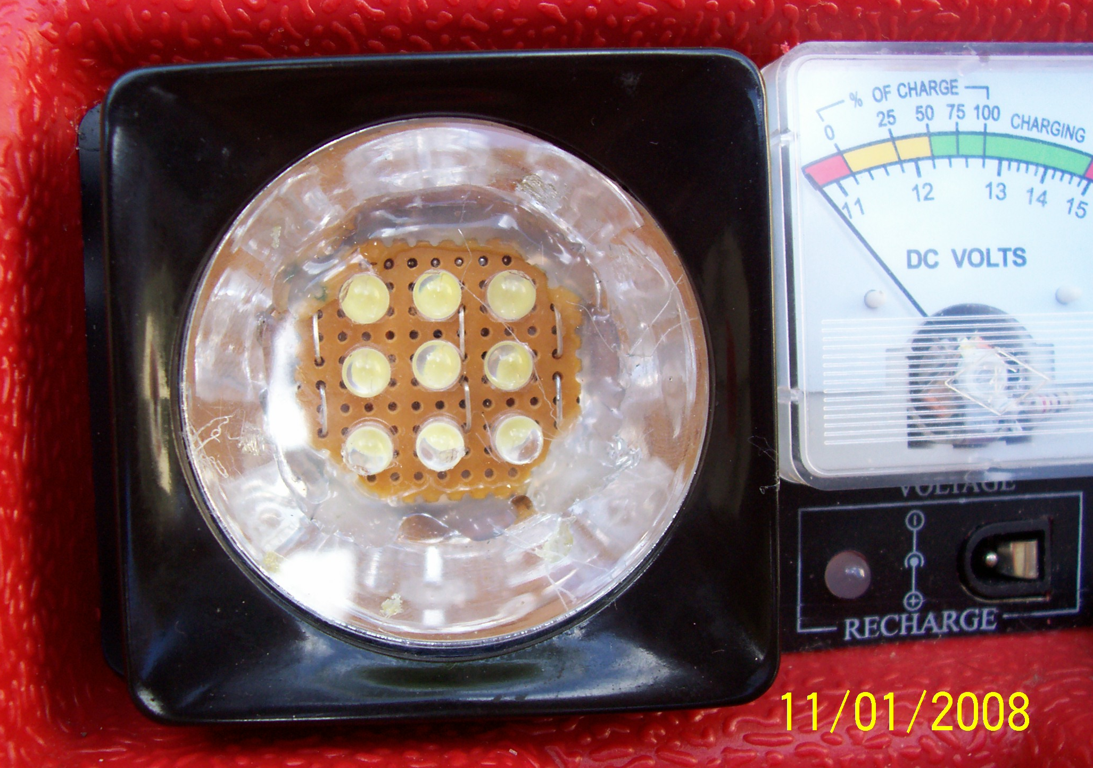

Controller PCB (Vero board) Description
The Controller PCB will use a Tiny15 microcontroller which will be powered by a 78L05 voltage regulator. The 78L05 can output up to 100mAmps at 5V. Because the LED’s will be driven by FET’s, the LED currents will not be sourced by the 78L05 so will not be included in the current output capacity of the 78L05 regulator.

Each of the white LED’s will typically drop 3.3V when turned on. We have 3 LED’s in series so this means when a LED branch is turned on, via the appropriate FET, we will be dropping 9.9V across the LED’s themselves. The 100Ω resistor placed in series with each LED branch will limit the current drawn to 20 mAmps as per the LED specifications (see heading The LED PCB).

The Tiny15 will control each of the LED branches via the following PORTB signals fed to the gate of an appropriate FET:
- PB0 – LED branch 1 (FET Q1)
- PB1 – LED branch 2 (FET Q2)
- PB2 – LED branch 3 (FET Q3)

Each of the above signals will be fed to the gate of an appropriate FET (Q1 to Q3) that will control the switching on and off of a GND to the appropriate LED branch. When the PORTB signal is LOW, the LED branch will be off. When the PORTB signal is HIGH the LED branch will be on.

The normally open (N/O) pushbutton switch will be connected between GND and PB3. Use of the Tiny15’s ability to attach a pull-up resistor (under software control) to 5V will allow detection of when the switch is pressed.

Figure 1 shows the current measurements taken from the 12V battery source for the 9 different brightness levels available (bear in mind the microcontroller uses about 6 or 7 mA at 5V):

brightness | current drawn | LED Bank 1 | LED Bank 2 | LED Bank 3
1 | 14.3 mA | on 33% | off | off
2 | 20.4 mA | on 66% | off | off
3 | 26.7 mA | on 100% | off | off
4 | 32.4 mA | on 100% | on 33% | off
5 | 38.2 mA | on 100% | on 66% | off
6 | 44.2 mA | on 100% | on 100% | off
7 | 49.6 mA | on 100% | on 100% | on 33%
8 | 55.0 mA | on 100% | on 100% | on 66%
9 | 60.76 mA | on 100% | on 100% | on 100%

Figure 1 – Current drawn from 12V supply

Putting The Hardware Together & Testing

LED PCB hot-glued to reflector
Microcontroller PCB
Brightness Switch

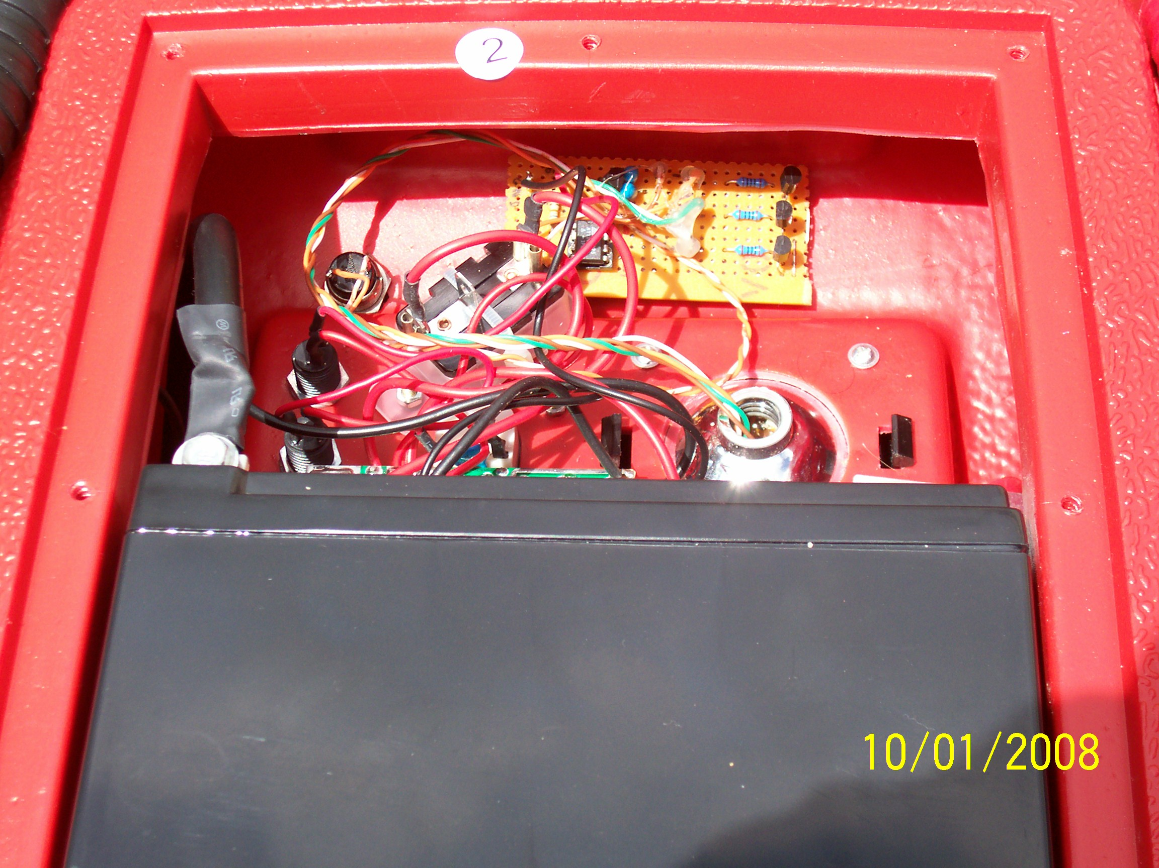

As constructed there were three sub assemblies built:
- The LED PCB with interconnect wiring.
- The Controller PCB with appropriate solder tabs.
- The Switch with interconnect wiring.

I did consider putting in connectors for the sub assemblies but then decided to hardwire the boards together. This meant less hardware and space on the Controller board (more work if a fault develops though I guess).

After the original incandescent lamp had been removed from the Jump Starter reflector the following construction actions were performed:
  - The LED PCB first had its’ interconnect wires fed through the reflector then the PCB was hot glued to the reflector. If we have a problem with this board at a later stage, the hot glue will have to removed to get access to the board.
  - The switch with it’s interconnect wiring was then inserted into the appropriately drilled hole in the Jump Starter casing.
  - The LED PCB and Switch were then connected to the Controller PCB by soldering the appropriate interconnect wires to the appropriate solder tabs.
  - The original GND and +12V wires from the units ‘light switch’ were soldered to the Controller PCB’s power solder tabs.
  - The Controller PCB was attached internally to the Jump Starter using Velcro strips. This will also allow for easy detachment of the Controller PCB from the Jump Starter in the case of problems.

After putting the unit together, testing was pretty basic. When the Light Switch (the GREEN ONE) was pressed there was a brief bright flash as all LED’s were illuminated then the default brightness level of 1 kicked in and only LED bank 1 was on for 33% of the time and provides a dim level of lighting.

In a tent it would not be a problem to leave the light at this level all night (you know, if you wake up and have to suddenly leave the tent you won’t be stumbling around bumping into things while looking for the torch).

When the brightness is turned up to full (9), it is bright enough to comfortably read a book. The light beam is a bit on the focused side because of the nature of LED’s but it is still a better option than the original incandescent globe.

I left the unit on for 4 days at full power (maximum brightness) with no problems occurring. The battery voltage was down to about 11.8V at this stage so I decided that 4 days continuous output means my original goal of making a better light had been achieved. When you do the math re 12 Amp Hours and 60 mA usage it may actually work for 8 days (but might not be so good for the battery).

Program Description
The program was written in AVR assembler using AVR Studio version 4.13.

The Interrupt vectors are defined at the beginning of the source code. There are only two vectors used by this software implementation, STARTUP and TIMO_OVF but for software security all possible interrupt vectors are catered for via appropriate RETI entries.

The Timer0 overflow interrupt TIMO_OVF has been set to interrupt every 3.3333 mSec and will perform two actions:
- decrement delay_cnt till it reaches zero
- increment cycle_cnt (from 1 to 3)

Depression of the N/O switch SW1 will increment the variable brightness and have a range of 1 (minimum light) to 9 (maximum light). When the switch is quickly depressed this will be detected in the main program loop and the variable brightness will be incremented (with wrap around checking) and then a delay will be established (a 333.33 mSec delay by setting delay_cnt to 100) before button depression is checked again in the main loop to allow for button debounce.

A complete cycle for all LED banks involves 3 cycles of 3.3333 mSEC meaning a complete LED display cycle time of approximately 10 mSEC. This allows a refresh rate of approximately 100Hz for the LED banks meaning no flickering should be observed.

Each value of brightness for an individual LED bank will involve 3 cycles of 3.3333 mSec and will allow for three different intensities on each LED bank (depending on variable brightness) meaning a total of 9 different levels of light output.

A table labeled LOOKUP will contain the LED branch settings for the 9 levels of brightness times the 3 levels of intensity cycle_count, resulting in a total of 27 bytes. The looping section of the program A_LOOP will use the variables brightness and cycle_count to load the appropriate LED branch patterns for each particular cycle and output this value to PORTB.

As can be seen in Figure 3 (which shows minimum illumination to maximum illumination), each brightness value B will involve control of the three banks of LED’s (LB1 to LB3) and will take three C cycles of 3.3333 mSec for each brightness level.
When powered on the light will be set to minimum brightness (i.e 1) and will have LED bank one illuminated at 33% on-time with LED banks 2 and 3 off. When the button is pressed it will result in LED bank 1 changing to 66% on-time with LED banks 2 and 3 off. Figure 2 shows the resulting LED bank waveforms (LB1 to LB3) after subsequent depressions of the switch and hence increments of brightness B.

LB1
LB2
LB3
B | 1 |  |  | 2 |  |  | 3 |  |  | 4 |  |  | 5 |  |  | 6 |  |  | 7 |  |  | 8 |  |  | 9
c | 1 | 2 | 3 | 4 | 5 | 6 | 7 | 8 | 9 | 10 | 11 | 12 | 13 | 14 | 15 | 16 | 17 | 18 | 19 | 20 | 21 | 22 | 23 | 24 | 25 | 26 | 27

Figure 2 – Minimum to Maximum Brightness cycles

Switch depression | LED Bank 1 illumination | LED Bank 2 illumination | LED Bank 3 illumination
Power-up (default) | 33% | 0% | 0%
1 | 66% | 0% | 0%
2 | 100% | 0% | 0%
3 | 100% | 33% | 0%
4 | 100% | 66% | 0%
5 | 100% | 100% | 0%
6 | 100% | 100% | 33%
7 | 100% | 100% | 66%
8 | 100% | 100% | 100%
9 | 33% | 0% | 0%

Figure 3 – LED Bank Illumination Switch Depressions

Source Code

;----------------------------------------
; register definitions
.def status = R2

.def temp = R16 ; general temporary register
.def tempa = R17 ; used in TIM0_OVF
.def tempb = R18 ; second temporary general register
.def brightness = R19 ; 1 to 9
.def cycle_cnt = R20 ; 1 to 3
.def del_cnt = R21 ; dec’d in TIM0_OVF

.equ CYCLE = 3 ; 1 to 3
.equ MAX = 10 ; Brightness
.equ FREQ = 0xAD ; 3.3333mSec
.equ SWITCH = 3 ; PB3

.cseg
;----------------------------------------
;Reset handler
.org $0000
rjmp STARTUP
;----------------------------------------
; INT0
reti
;----------------------------------------
; Pin Change
reti
;----------------------------------------
; Timer1 Compare
reti
;----------------------------------------
;Timer 1 Overflow
reti
;----------------------------------------
;Timer0 overflow handler
rjmp TIM0_OVF
;----------------------------------------
; Eprom ready
reti
;----------------------------------------
;Analogue Compare
reti
;----------------------------------------
;ADC Conversion
reti
;-------------------------------------------
; TIMER0 Overflow Interrupt
; dec cycle_cnt and del_cnt till zero
;-------------------------------------------
;
TIM0_OVF:
in status,SREG ; save the status register at entry
ldi tempa,FREQ
out TCNT0,tempa ; restart TIMER0
; if del_cnt is non-zero, dec till 0
tst del_cnt ; is del_cnt non-zero?
breq TIM_O1 ; no!
dec del_cnt ; yes so dec it
; cycle_cnt goes from 1 to 3
TIM_O1:
inc cycle_cnt ; inc cycle_cnt
cpi cycle_cnt,CYCLE+1 ; wrap around?
brne TIM_02 ; no!
ldi cycle_cnt,1 ; yes! Reset to 1
TIM_02:
out SREG,status ; restore status register at exit
reti

;----------------------------------------
; LED lookup table
;----------------------------------------
LOOKUP:
.DB 0x01,0x00,0x00,0x01,0x01,0x00,0x01,0x01,0x01,0x03,0x01,0x01,0x03,0x03,0x01,0x03,0x03,0x03,0x07,0x03,0x03,0x07,0x07,0x03,0x07,0x07,0x07

;----------------------------------------
; This is where we setup the ports and peripherals
;----------------------------------------
;
STARTUP:
; PB0,PB1,PB2 are outputs
ldi temp,0x07
out DDRB,temp
; Pull-ups enabled PB3 for SW1
ldi temp,0x08
out PORTB,temp
; set up internal oscillator
ldi temp,0x60
out OSCCAL,temp
; CLK/64 3.333 mSec clock
ldi temp,0x03
out TCCR0,temp
ldi temp,0
out TCCR1,temp
; Timer 0 Overflow interrupts 3.3 mSec
ldi temp,(1<<TOIE0)
out TIMSK,temp
; set up timer0
ldi temp,FREQ
out TCNT0,temp
; set up initisl variables
ldi cycle_cnt,1
ldi brightness,1
sei ; enable interrupts

;----------------------------------------
; This is where the program loops
;----------------------------------------
;
A_LOOP:
tst del_cnt ; are we delaying?
brne A_LOOP10 ; yes! So no switch checking!
sbic PINB,SWITCH ; no! Is button pressed?
rjmp A_LOOP10 ; no!
inc brightness ; yes! So inc brightness
ldi del_cnt,100 ; don’t check button for 330 mSec
cpi brightness,MAX ; wrap around?
brne A_LOOP10 ; no!
ldi brightness,1 ; yes!
; We will set the pointer to the start of the appropriate ‘1 of 3’ byte patterns
; in the table LOOKUP. Then we will add the cycle_cnt number to the pointer
; to point to the appropriate display pattern.
A_LOOP10:
ldi ZH, high(LOOKUP<<1) ; Initialize Z pointer to LOOKUP
ldi ZL, low(LOOKUP<<1)
mov temp,brightness
A_LOOP12:
dec temp ; allow for 1 origin
breq A_LOOP15 ; if eq 0 1st time then at start of table
ldi tempb,3 ; else add 3 (next brightness level)
add ZL,tempb
rjmp A_LOOP12 ; back for more
A_LOOP15:
add temp,cycle_cnt ; offset to cycle_cnt byte
dec temp ; allow for 1 origin
add ZL,temp ; now pointing at LED pattern
lpm ; R0 has LED pattern
ldi temp,0x08
or R0,temp ; make sure SWITCH pullup is high
out PORTB,R0 ; O/P LED state
rjmp A_LOOP

Circuit Diagram
